**GMOBooks User Manual**

**Background**

GBObooks was meticulously crafted to offer users a streamlined approach to search through an extensive collection of GMO Books, enabling them to locate their desired book with ease. The platform presents comprehensive information, including the book's publisher, country of publication, and media type, empowering users to make informed choices.

**Landing Page**

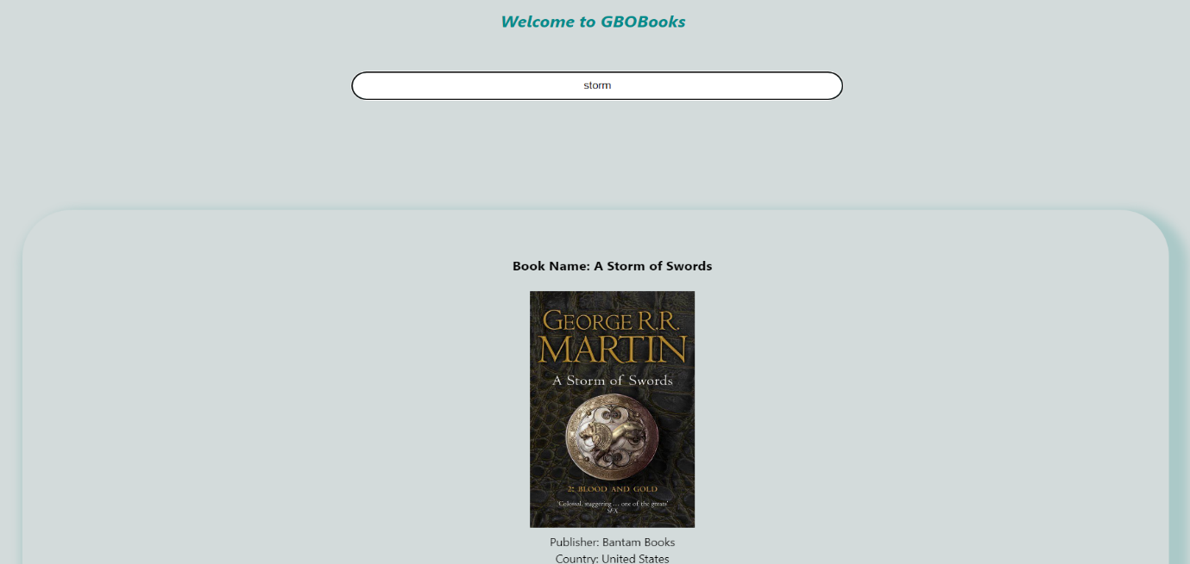

**Search**

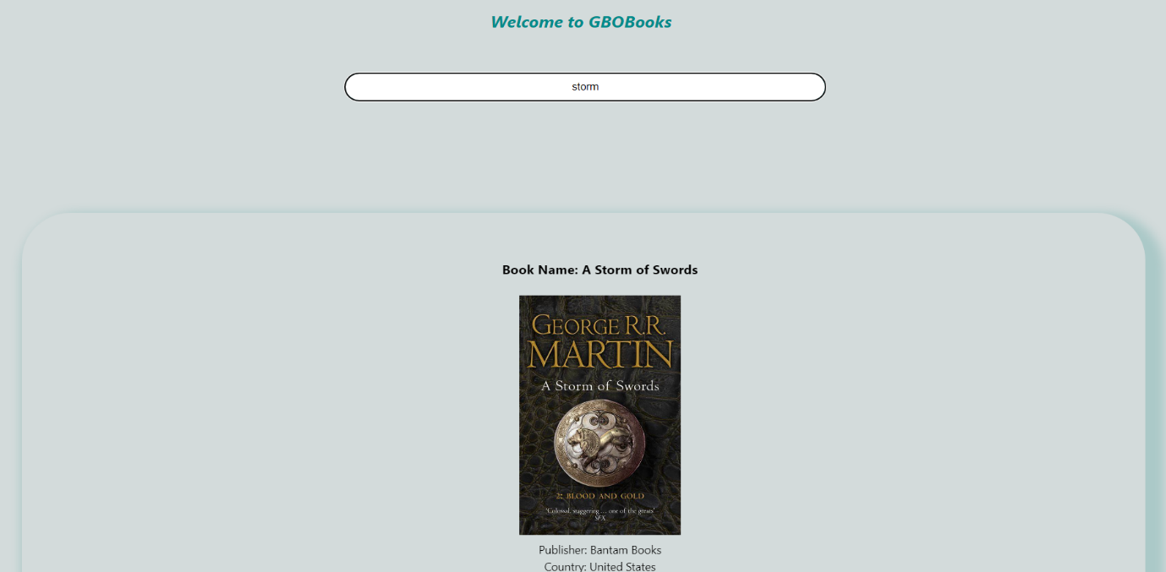

**Instructions**

Search for the name of the book you would like to find